10/14/2023 document

# Formula Derivation

From reference paper:

It is described by the Beer-Lambert Law , which relates the exponential decay of incident light intensity entering a medium (I0) to the light intensity reaching a detector (Idet ) using the optical properties and composition of the medium (µa) and the path-length photons take to get to the detector (L).

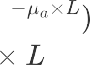





This can be rewritten in terms of temporal changes in light absorption (∆A) and expanded to incorporate multiple tissues (i) with the Modified Beer-Lambert Law.





This definition can liberate μa and L from the exponential. And ensure that ΔA is a positive number.

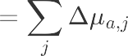



# One subject forward Model idea

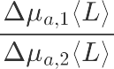

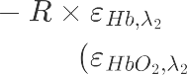

## Step1: Fitting real experimental data with simulated data

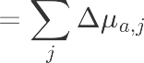



At a specific wavelength, we can use the L-ppath data of the simulation data to fit the AC/DC ratio of the real data to determine the reasonable range of Δμa(The μa used in Monte Carlo is the initial μa, based on the reference paper).

## Step2: Fitting at two wavelengths

We already have Monte Carlo simulation data and real experimental data at two wavelengths(735/850nm),. If obtained we can repeat the above process and fit the real experimental data at both wavelengths.

## Step3: Spo2 check method



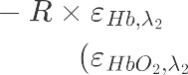

Get R from the data at two wavelengths, then calculate Spo2, and judge whether the value is reasonable according to the experiment Spo2 of individual sheep.

## Step4: Different SD (as close as possible) modified geometry/curvature

In real experimental data, we have two channels representing different SD. We can modify the model geometry by changing the SD of the detector in the simulation codes.

# Two subjects (Mom and fetus)

From raw data adaptive noise cancelation (small SD and large SD):

(1) AC mom; (2) AC fetus; (3) DC parts from mom and fetus.

## Methods to get fetus DC:

1. From adaptive noise cancelation of the experimental raw data.
2. Extract the fetal DC part from the perspective of formula.





## Step1: Short SD to get the fix Δμa

Run short SD distance and know the parameter , based on the experiment data, we can get Δμa.

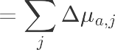



Plug the Δμa to the MC simulation and check (similar as the one subject) and get the fix Δμa. (DC ratio for *mom and* baby through MC simulation)

## Step2: Long SD to focus on fetus

Run long SD distance, set μa of mom stable and focus on fetus.

From experiment data we can get $-\ln\left(\frac{I_{dia_{fetus}}}{I_{sys_{fetus}}}\right)$ and from MC simulation we and get $L_{j_reachfetus}$.

Fine tuning the Δμa to satisfy the formula $-\ln\left(\frac{I_{dia_{fetus}}}{I_{sys_{fetus}}}\right)=\sum_{j}{{Δμ}_{a,j, fetus}×L_{j_reachfetus}}$